Task 1: Taint a Node and Schedule a Tolerant Pod Taint a node with special=true:NoSchedule. Create a pod with a toleration that matches the taint, allowing it to be scheduled on the tainted node.

Step 1: Taint the Node

kubectl get nodes

Run this command to taint k8s-worker-01:

kubectl taint nodes k8s-worker-01 special=true:NoSchedule

Verify taint:

kubectl describe node k8s-worker-01 | grep Taints

Example output:

Taints: special=true:NoSchedule

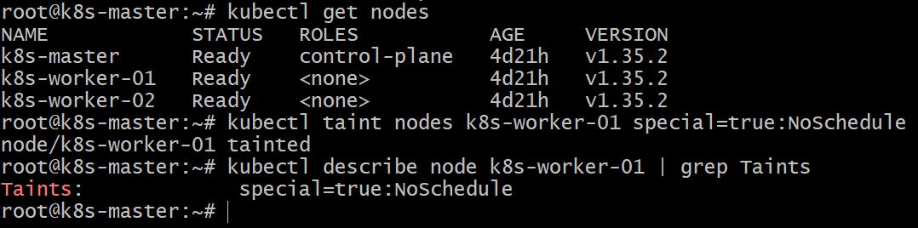

Step 2: Create Pod YAML with Toleration

Create file `toleration-pod.yaml`

vi toleration-pod.yaml

apiVersion: v1
kind: Pod
metadata:
name: tolerant-pod
spec:
nodeSelector:
kubernetes.io/hostname: k8s-worker-01
tolerations:
- key: "special"
operator: "Equal"
value: "true"
effect: "NoSchedule"
containers:
- name: nginx-container
image: nginx

Explanation:

* tolerations → allows pod to run on tainted node
* nodeSelector → forces pod to schedule on `k8s-worker-01`

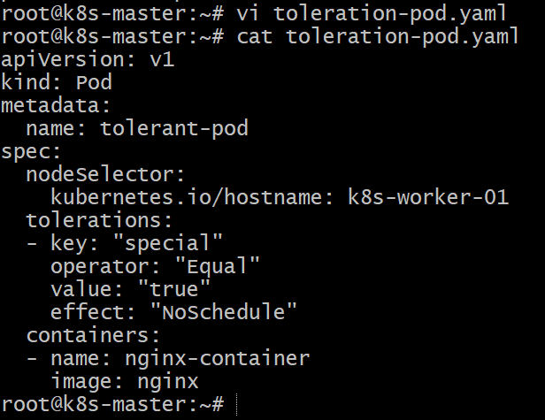

Step 3: Apply the Pod

kubectl apply -f toleration-pod.yaml

Output:

pod/tolerant-pod created

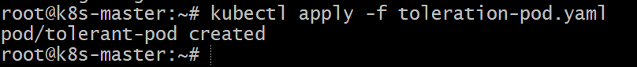

Step 4: Verify Pod Scheduling

Check pod location:

kubectl get pods -o wide

Example output:

NAME READY STATUS NODE
tolerant-pod 1/1 Running k8s-worker-01

The pod runs on k8s-worker-01 because it tolerates the taint.

Step 5: Test

Try creating a normal pod without toleration:

kubectl run test-pod --image=nginx

Check:

kubectl get pods -o wide

It will not schedule on k8s-worker-01 because of the taint.

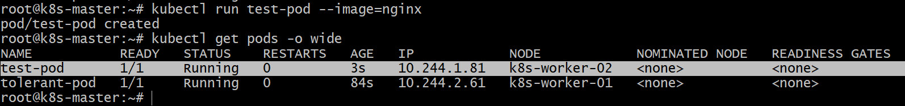

Conclusion

In this task, we applied a taint (`special=true:NoSchedule`) to `k8s-worker-01`, which prevents pods from being scheduled on that node unless they explicitly tolerate the taint. We then created a pod with a matching toleration and nodeSelector, allowing it to run on the tainted node. This demonstrates how taints and tolerations control pod scheduling in Kubernetes clusters.

Task 2: Use NodeSelector to Schedule a Pod on a Specific Node Label a node with env=dev. Create a pod with a nodeSelector that schedules it only on the node labeled env=dev.

Step 1: Label the Node

kubectl get nodes

Label k8s-worker-02 with `env=dev`.

kubectl label nodes k8s-worker-02 env=dev

Verify the label:

kubectl get nodes --show-labels

Example output:

NAME STATUS ROLES LABELS
k8s-worker-02 Ready <none> env=dev

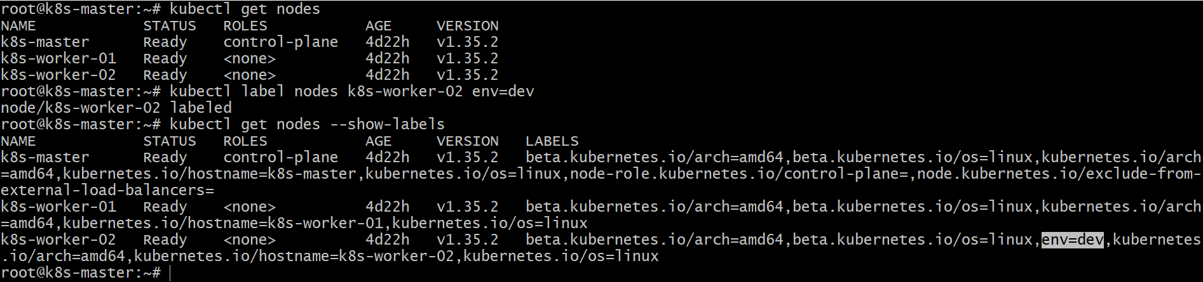

Step 2: Create Pod YAML with NodeSelector

Create a file called `node-selector-pod.yaml`

vi node-selector-pod.yaml

apiVersion: v1
kind: Pod
metadata:
name: dev-pod
spec:
nodeSelector:
env: dev
containers:
- name: nginx-container
image: nginx

Explanation:

* nodeSelector: env=dev ensures the pod is scheduled only on nodes with that label.

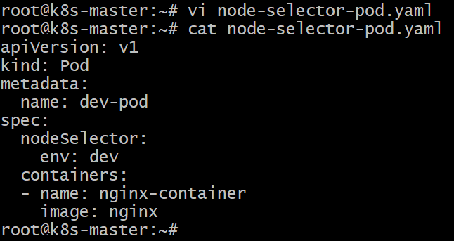

Step 3: Apply the Pod

kubectl apply -f node-selector-pod.yaml

Expected output:

pod/dev-pod created

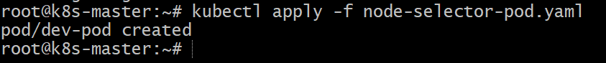

Step 4: Verify Pod Scheduling

kubectl get pods -o wide

Example output:

NAME READY STATUS NODE
dev-pod 1/1 Running k8s-worker-02

The pod runs on k8s-worker-02 because it has the label env=dev.

Conclusion

In this task, we labeled a node (`k8s-worker-02`) with env=dev and created a pod with a nodeSelector to ensure it is scheduled only on nodes with that label. This demonstrates how Kubernetes uses node labels and selectors to control pod placement on specific nodes in the cluster.

Task 3: Use Node Affinity with Soft Scheduling Label a node with env=test. Create a pod with PreferredDuringSchedulingIgnoredDuringExecution node affinity, preferring to schedule it on a node
labeled env=test. Remove the label and verify the pod continues to run.

Step 1: Label the Node

kubectl get nodes

Add label env=test to `k8s-worker-02`.

kubectl label nodes k8s-worker-02 env=test

Verify:

kubectl get nodes --show-labels

You should see:

k8s-worker-02 Ready <none> env=test

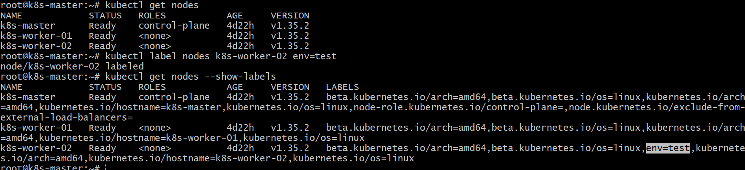

Step 2: Create Pod YAML with Preferred Node Affinity

Create file `node-affinity-pod.yaml`

vi node-affinity-pod.yaml

apiVersion: v1
kind: Pod
metadata:
name: affinity-pod
spec:
affinity:
nodeAffinity:
preferredDuringSchedulingIgnoredDuringExecution:
- weight: 1
preference:
matchExpressions:
- key: env
operator: In
values:
- test
containers:
- name: nginx-container
image: nginx

Explanation:

* preferredDuringSchedulingIgnoredDuringExecution → soft rule (preferred but not mandatory)
* Scheduler tries to place the pod on nodes with `env=test`.

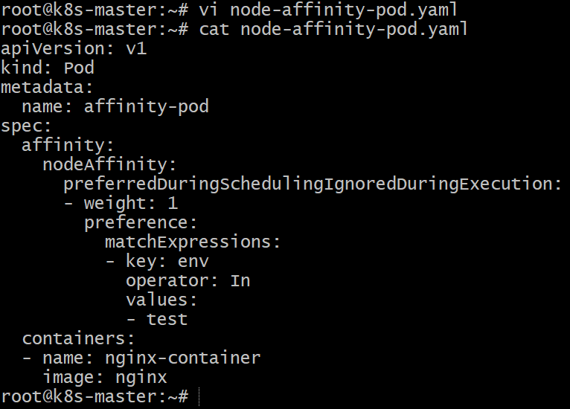

Step 3: Apply the Pod

kubectl apply -f node-affinity-pod.yaml

Verify:

kubectl get pods -o wide

Example output:

NAME READY STATUS NODE
affinity-pod 1/1 Running k8s-worker-02

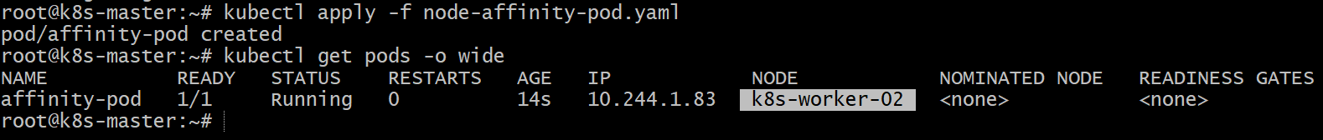

Pod prefers k8s-worker-02 because it has label env=test.

Step 4: Remove the Node Label

Remove the label:

kubectl label nodes k8s-worker-02 env-

Verify:

kubectl get nodes --show-labels

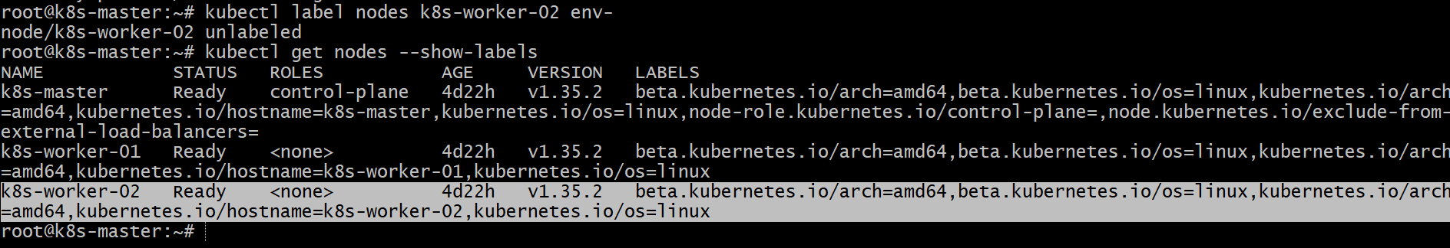

Step 5: Verify Pod Status

Check pod again:

kubectl get pods -o wide

Output example:

NAME READY STATUS NODE
affinity-pod 1/1 Running k8s-worker-02

The pod continues running even after removing the label.

Reason:
`IgnoredDuringExecution` means existing pods are not affected if labels change.

Conclusion

In this task, we labeled a node with env=test and created a pod using PreferredDuringSchedulingIgnoredDuringExecution node affinity, which acts as a soft scheduling rule. The scheduler preferred placing the pod on the labeled node. After removing the label, the pod continued running because soft node affinity rules only affect scheduling and not running pods.

Task 4: Implement Node Affinity with Hard Scheduling Create a pod with RequiredDuringSchedulingIgnoredDuringExecution node affinity, ensuring it will only be scheduled on a node labeled env=prod. Verify the pod cannot be scheduled if no node has the env=prod label.

Step 1: Verify No Node Has `env=prod`

kubectl get nodes --show-labels

Ensure no node has `env=prod` label.

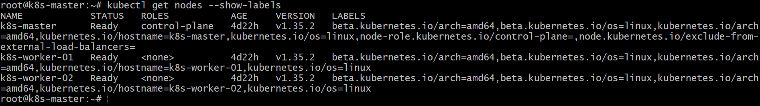

Step 2: Create Pod YAML with Required Node Affinity

Create file `hard-affinity-pod.yaml`

vi hard-affinity-pod.yaml

apiVersion: v1
kind: Pod
metadata:
name: prod-affinity-pod
spec:
affinity:
nodeAffinity:
requiredDuringSchedulingIgnoredDuringExecution:
nodeSelectorTerms:
- matchExpressions:
- key: env
operator: In
values:
- prod
containers:
- name: nginx-container
image: nginx

Explanation:

* requiredDuringSchedulingIgnoredDuringExecution → hard scheduling rule
* Pod will only run on nodes labeled `env=prod`

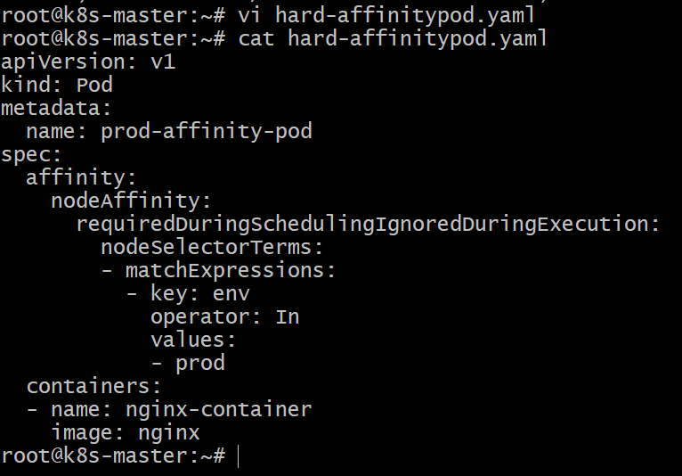

Step 3: Apply the Pod

kubectl apply -f hard-affinity-pod.yaml

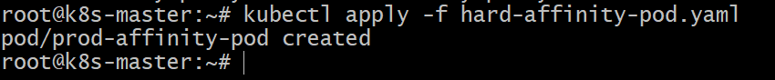

Step 4: Verify Pod Scheduling

kubectl get pods

Example output:

NAME READY STATUS AGE
prod-affinity-pod 0/1 Pending 10s

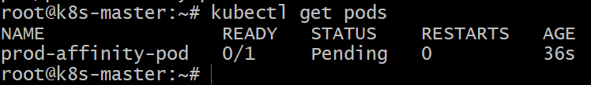

Check details:

kubectl describe pod prod-affinity-pod

You will see a message like:

0/3 nodes are available: node(s) didn't match Pod's node affinity.

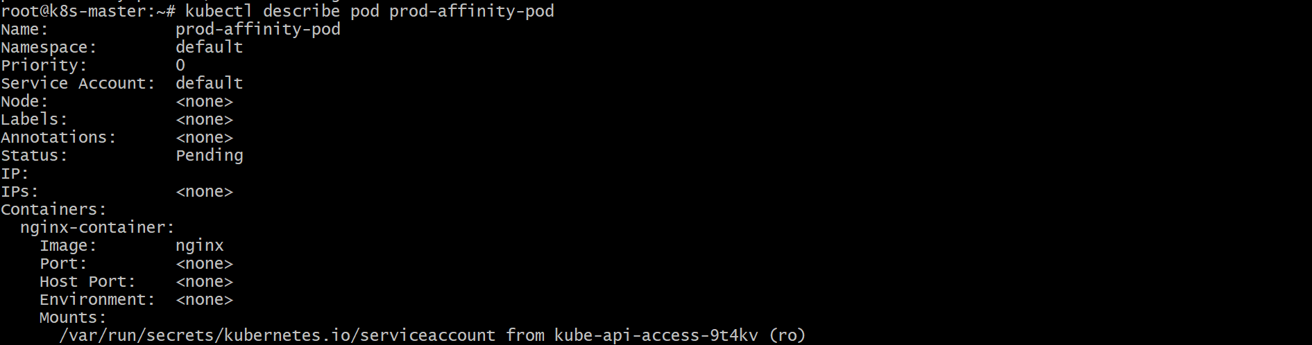

This confirms the pod cannot be scheduled.

Step 5: Add the Required Label (Optional Test)

Label a worker node:

kubectl label nodes k8s-worker-01 env=prod

Check again:

kubectl get pods -o wide

Example output:

NAME READY STATUS NODE
prod-affinity-pod 1/1 Running k8s-worker-01

Now the pod schedules successfully.

Conclusion

In this task, we implemented hard node affinity using `RequiredDuringSchedulingIgnoredDuringExecution`. The pod was configured to run only on nodes labeled env=prod. Since no nodes initially had this label, the pod remained Pending. After labeling a node with env=prod, the pod was successfully scheduled. This demonstrates how hard node affinity strictly controls pod placement in Kubernetes.

Task 5: Taint a Node and Use NoExecute with Toleration Seconds Taint a node with special=true:NoExecute. Create a pod with a tolerationSeconds field (e.g., 60 seconds) and observe it gets evicted after 60 seconds on the tainted node.

Step 1: Taint the Node

kubectl get nodes

Apply the taint to k8s-worker-01.

kubectl taint nodes k8s-worker-01 special=true:NoExecute

Verify:

kubectl describe node k8s-worker-01 | grep Taints

Example output:

Taints: special=true:NoExecute

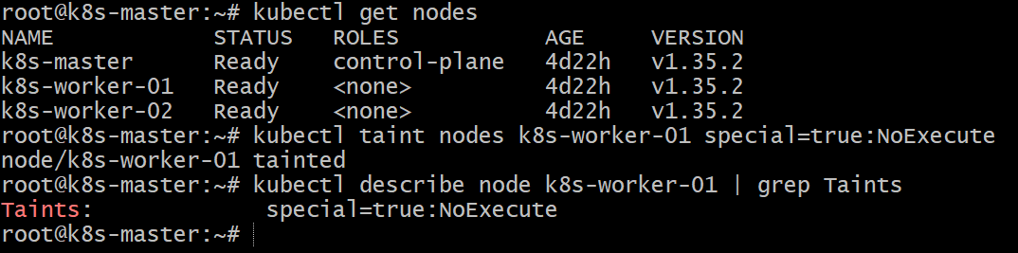

Step 2: Create Pod YAML with `tolerationSeconds`

Create file `noexecute-pod.yaml`

vi noexecute-pod.yaml

apiVersion: v1
kind: Pod
metadata:
name: tolerate-pod
spec:
nodeSelector:
kubernetes.io/hostname: k8s-worker-01
tolerations:
- key: "special"
operator: "Equal"
value: "true"
effect: "NoExecute"
tolerationSeconds: 60
containers:
- name: nginx-container
image: nginx

Explanation:

* NoExecute → evicts existing pods without toleration
* tolerationSeconds: 60 → pod stays for 60 seconds, then gets removed

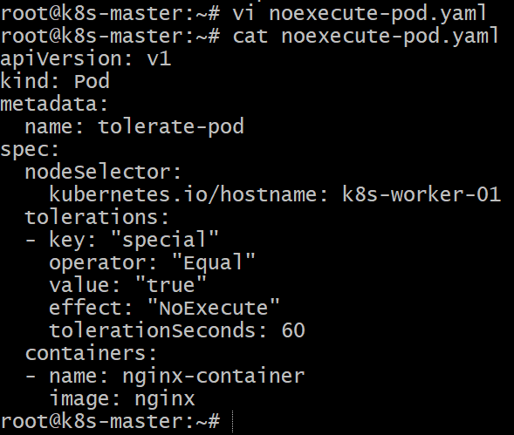

Step 3: Apply the Pod

kubectl apply -f noexecute-pod.yaml

Verify:

kubectl get pods -o wide

Example:

NAME READY STATUS NODE
tolerate-pod 1/1 Running k8s-worker-01

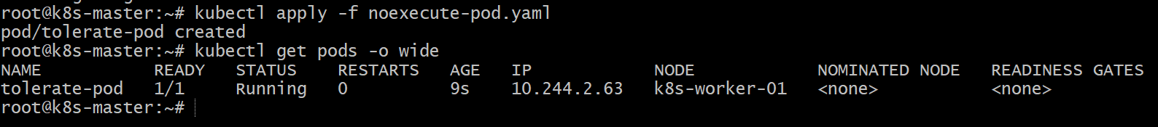

Step 4: Observe Pod Eviction

Wait about 60 seconds, then check:

kubectl get pods
kubectl get pods -w

You may see:

NAME READY STATUS
tolerate-pod 0/1 Terminating

Or it may already be deleted/evicted.

Check events:

kubectl describe pod tolerate-pod

Example event:

Pod was evicted due to taint special=true:NoExecute

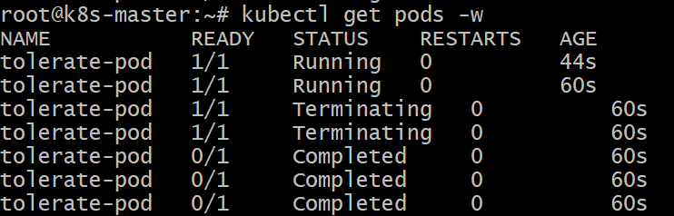

Conclusion

In this task, we applied a NoExecute taint (`special=true:NoExecute`) to `k8s-worker-01`. A pod with a matching toleration and `tolerationSeconds=60` was able to run on the tainted node temporarily. After 60 seconds, Kubernetes automatically evicted the pod, demonstrating how NoExecute taints control both scheduling and runtime eviction of pods.

